**HEIMDALL CIRCUIT:**

**WIRING DIAGRAM:**

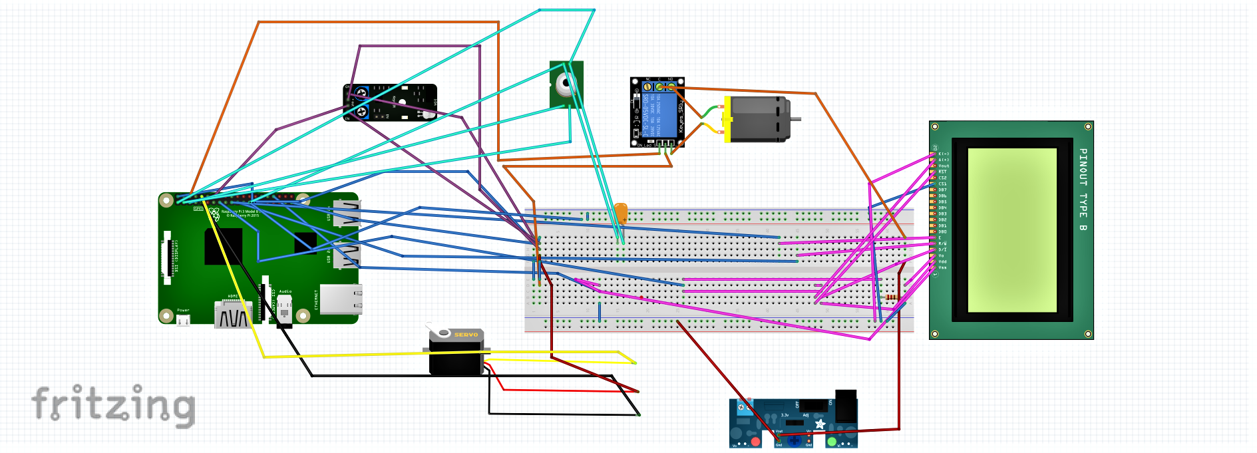

**CONNECTING THE RASPBERRY PI 4 WITH THE RPI CAMERA MODULE V2:**

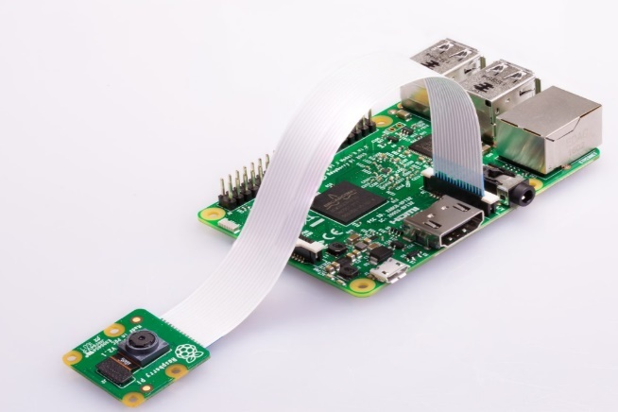

**PIN DIAGRAMS/ PARTS EXPLANATION DIAGRAMS:**

Raspberry Pi 4:

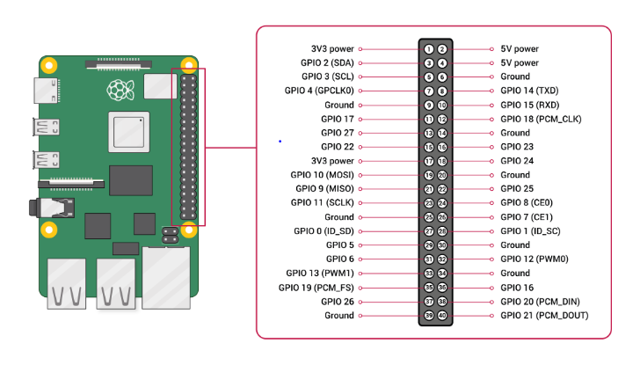

Infrared Thermometer MLX90614:

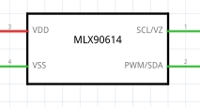

Servo Motor:

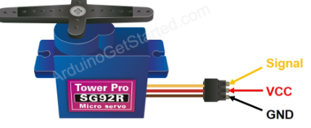

IR Proximity Sensor:

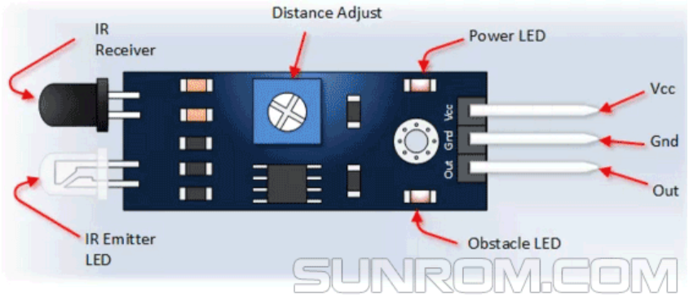

DC Water Pump:

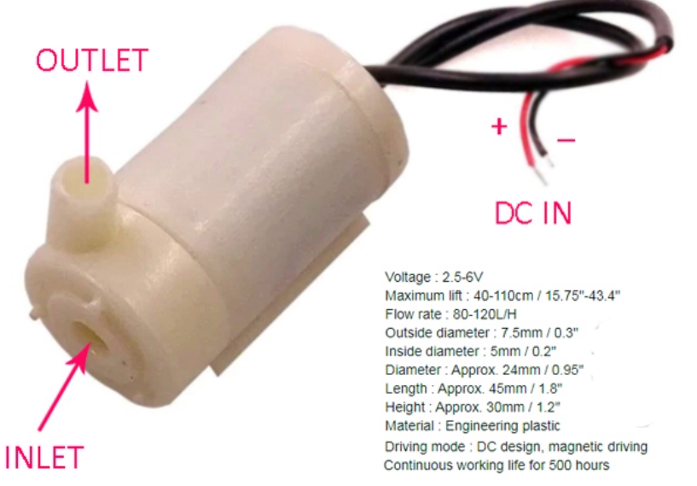

128X64 LCD Graphic Display:

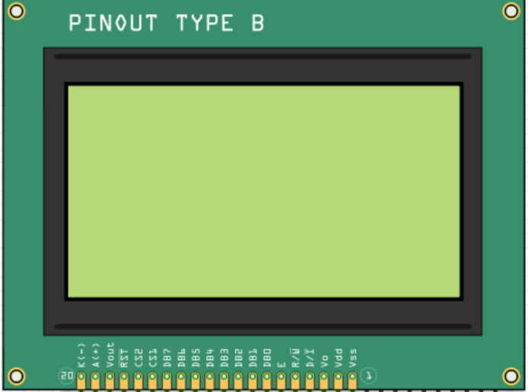

Relay:

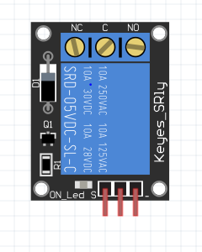

Adjustable Breadboard Power Supply:

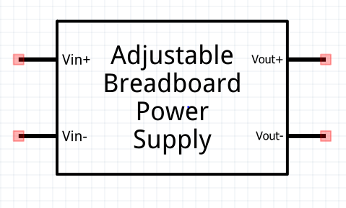

**CIRCUIT INSTRUCTIONS:**

1. Collect all electronic components and parts required for the circuit.
2. Connect the RPi Camera Module V2 to the Raspberry Pi 4.
3. Begin with powering up the Raspberry Pi by connecting it to a 5V DC source, through a USB Cable.
4. The Servo motor has 3 wires, of which the black wire is connected to the ground, Red to the 5V Pin and Yellow to a GPIO pin of the Raspberry Pi 4.
5. The IR Proximity sensor has 3 pins. Connect the GND and Out pins to the ground of the RPi 4. Connect Vcc ( and enable, if sensor has 4 pins) to the 5V Pin of the Raspberry Pi.
6. To connect the MLX90614 Infrared thermometer with the Raspberry Pi, first connect a capacitor between the Vdd and Vss terminals of the IR Thermometer.
7. From MLX90614 to Raspberry Pi 4, connect Vdd to 3.3v, Vss to GND, SCL/VZ to GPIO3, and PWM/SDA to GPIO2.
8. To connect the DC Submersible water pump ( DC motor in the wiring diagram) with the Raspberry Pi 4, a relay is used.
9. The Relay has 6 terminals. Connect one terminal of the dc pump to the NO of relay and the other terminal of the dc pump to the GND pin of relay.
10. The remaining pins of the relay, the Signal pin is connected to a GPIO pin, C pin to a 12V supply and the IN pin to the GND of the Raspberry Pi 4.
11. An adjustable breadboard supply is used for the 12v DC supply. 12V is drawn from Vout+ to the circuit, GND is grounded and the AC supply is provided at Vin+ and Vin- pins.
12. Connecting the 128x64 Graphic LCD display with the Raspberry Pi: Ground the Vss, CS1 and K- pins of the display.
13. Connect Vdd, D/I, and A+ of the display to the 3.3V Supply Pin of Raspberry Pi.
14. Connect the Vo pin of the Graphic LCD display, to a variable resistance (set to 10k ohms). With one end of the resistor grounded and the other connected to the 3.3V Supply Pin of Raspberry Pi.
15. R/W and Enable of the 128x64 Graphic LCD is connected to the GPIO9 and GPIO10 pins of the Raspberry Pi.